Memorandum of Cooperation

Between

Members Of Parliaments On Promoting Knowledge Exchange And Strengthening Of transparency And Accountability In The Europe And Central Asian Regions

participating at the International Conference “Transparency and Accountability for Effective Oversight: the role of Parliament” organized by the MPs, members of the Serbian Chapter of the Global Organization of Parliamentarians against Corruption (GOPAC) in the National Assembly of the Republic of Serbia, and United Nations Development Programme in Serbia

We, the participants of the Conference “Transparency and Accountability for Effective Oversight: the Role of Parliament”, taking place on 21-22 May 2015 in Belgrade, Serbia (hereinafter referred to as “Participants”),

Recognizing that corruption impedes economic sustainability and development, threatens social security and fairness, undermines the rule of law, and erodes government accountability, as well as public trust,

Committed to sharing best practices in enhancing transparency, accountability towards effective parliamentary oversight and in particular financial oversight,

Acknowledging that increased global connectivity demands vigorous international cooperation to successfully combat corruption,

Recognizing the importance of joint efforts to promote fight against corruption, increase transparency and accountability of public institutions as the core principles of performing parliamentary oversight function,

Emphasizing the importance of promoting networking amongst parliamentarians committed to promote the values of transparency and accountability towards effective oversight,

Determined to create a platform for cooperation between parliamentarians towards sharing best practices between MPs and peers, enabling their exchange and coordination in regard to promoting principles of transparency, accountability and good governance,

Have reached an understanding on the following:

Article 1
General

All participants affirm their intent to cooperate jointly in the development and implementation of activities aimed to promote the need to fight against corruption, increase transparency and accountability of public institutions as the core principle of performing parliamentary oversight function, in their respective countries and the region.

The intention of this Memorandum on Cooperation (hereinafter “Memorandum”) is to create a framework of cooperation between parliamentarians from the countries of Europe and Central Asia Region, primarily on identifying modalities for increased transparency and accountability of public institutions.

Article 2
Cooperative activities

In implementing the provisions of this Memorandum, the following forms of cooperation may be considered:
- Organization of joint conferences, seminars, workshops, meetings, training sessions and outreach and education programmes;
- Support for collaborative projects, including joint legal initiatives, research projects, studies, reports, and policy development;
- Sharing information on national policies and programs subject to the respective country’s laws and regulations;
- Facilitation of linkages among politicians, civil society organizations and international organizations in promoting the exchange of best anti-corruption practices;
- Other forms of cooperation that participating parliamentarians deem appropriate.
Article 3
Areas of cooperation

The cooperation will be organized in the following areas:
- Promote greater integrity in parliaments;
- Awareness raising on anti-corruption practices and policies towards promoting the culture of fight against corruption;
- Transparency and accountability of public institutions;
- Enhancing parliamentary oversight;
- Control of public finance spending;
- Implementation of international anti-corruption instruments.
- Forming Regional GOPAC Chapter and activities pursuant thereunto.

Article 4
Funds

With the formation of this platform for cooperation we will with the United Nations Development Programme (UNDP) develop project and analyze regulatory frameworks on ethics, transparency and probity within in each parliament and jointly to improve management and dissemination of good practices that support strengthening of parliaments and their roles. All cooperative activities under this Memorandum are subject to the availability of funds. The funds may also be obtained from respective parliaments or other donor organizations.

Article 5
Concluding provisions

Cooperation under this Memorandum may commence upon its signature by the participants.

The participants plan to meet at least once a year to review the status of cooperation under this Memorandum. This Memorandum may be updated and modified in writing at each successive meeting.

Signed in Belgrade, on 22nd May 2015, by:

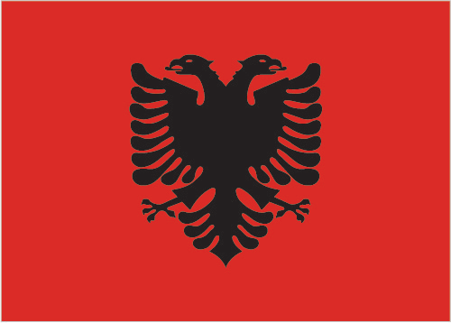  Albania | Namik DOKLE | ________________________________________
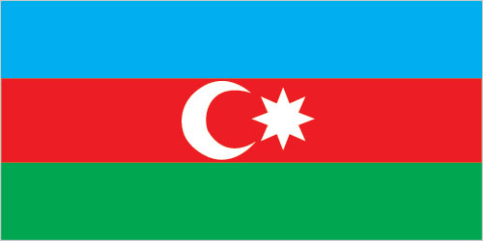  Azerbaijan | Ali HUSEYNLI | ________________________________________
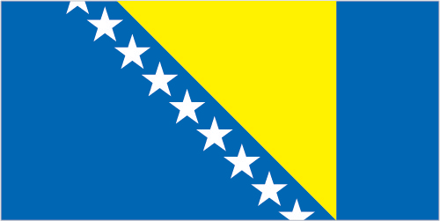  Bosnia and Herzegovina | Darko BABALJ  Predrag KOZULJ | ________________________________________  ________________________________________
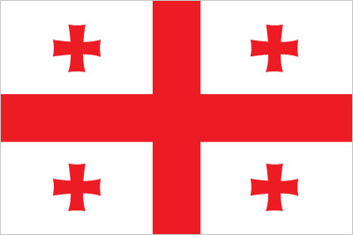  Georgia | Giorgi KAKHIANI | ________________________________________
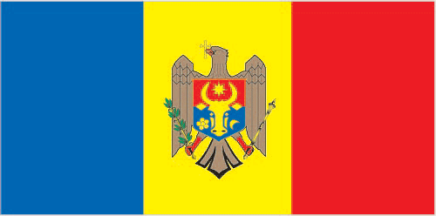  Moldova | Anatolie GORILA | ________________________________________
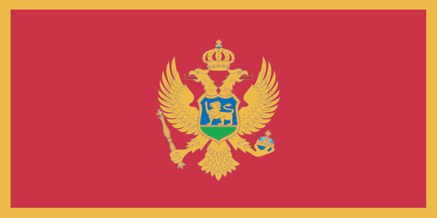  Montenegro | Predrag BULATOVIC  Srdjan PERIC | ________________________________________  ________________________________________
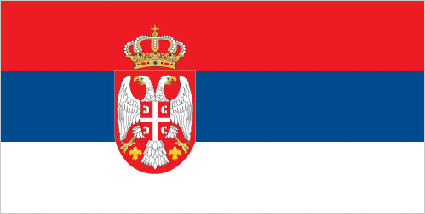  Serbia | Olgica BATIC | ________________________________________

